Operating Systems Lab FINAL EXAM

Name: Ahmed Kasteer

Roll Number: 20F-0336

Section: 4D

**Question 3:**

**#!/bin/bash**

**int arr[] = {0}**

**int n = 0**

**int x = 0**

**echo "Kindly enter the number of elements for array."**

**read n**

**for (int i=0; i < n; i++)**

**{**

**read ("%d", x)**

**arr[i] = x ;**

**sum = sum + arr[i]**

**if (sum = arr[i]+arr[i+1]**

**then**

**echo arr[i]**

**echo arr[i+1]**

**}**

**fi**

**}**

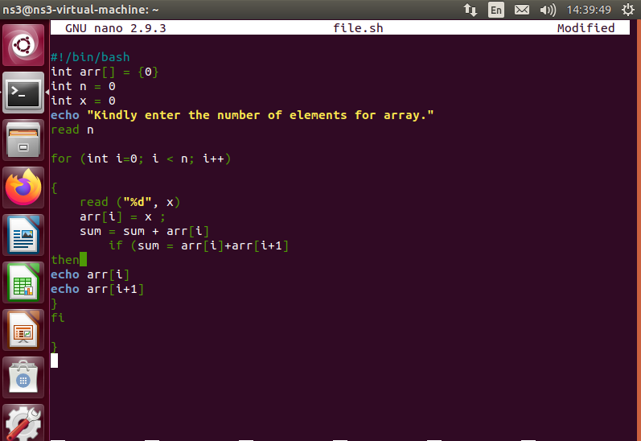

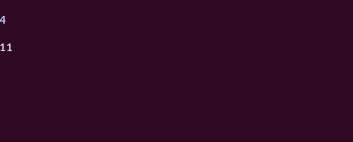

**Question 4:**

**#!/bin/bash**

**int id_num**

**int first_name**

**int last_name**

**int study_field**

**int gpa**

**int n = 0**

**echo " Enter number of students"**

**read n**

**for (int i; i < n; i++)**

**{**

**echo "Enter ID number"**

**read id_num**

**echo"Enter First name of student"**

**read first_name**

**echo "Enter last name of student"**

**read last_name**

**echo "Enter Study field of student"**

**read study_field**

**echo "Enter gpa of student"**

**read gpa**

**}**

**for (int j = 0; j < n; j++)**

**{**

**if (studyfield == "English"**

**if(gpa > 3.5**

**then**

**echo id_num**

**echo first_name**

**echo last_name**

**echo study_field**

**echo gpa)fi**

**)fi**

**)**

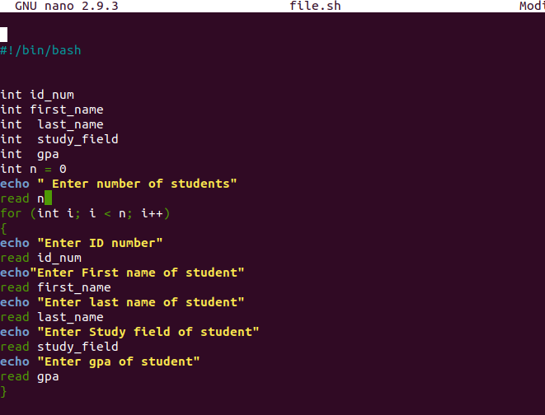

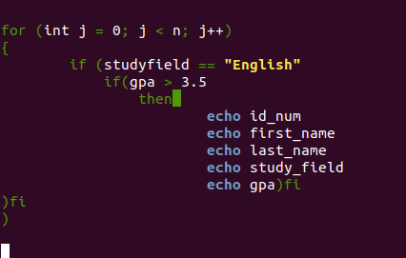

**Question 5:**

**i)**

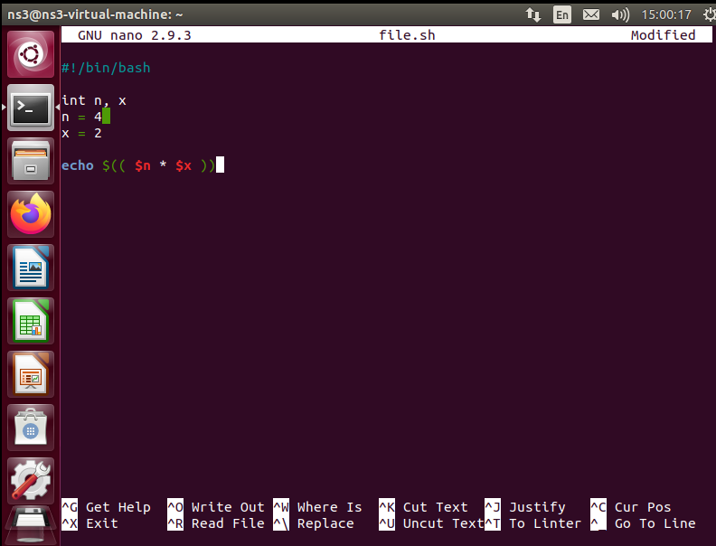

**ii)**

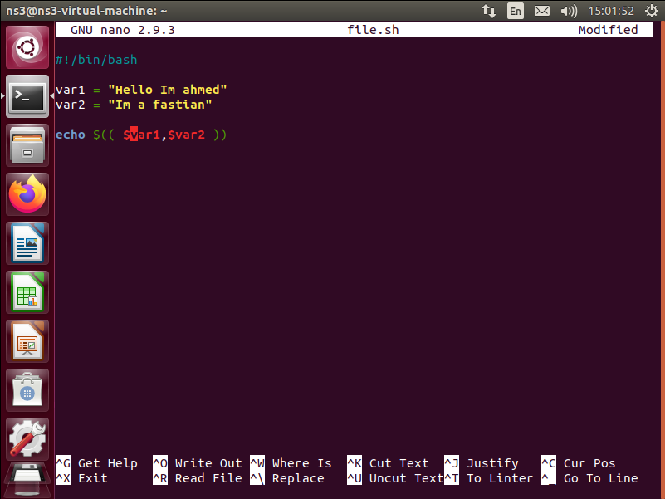

**v)**

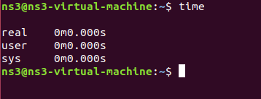

**vi)**

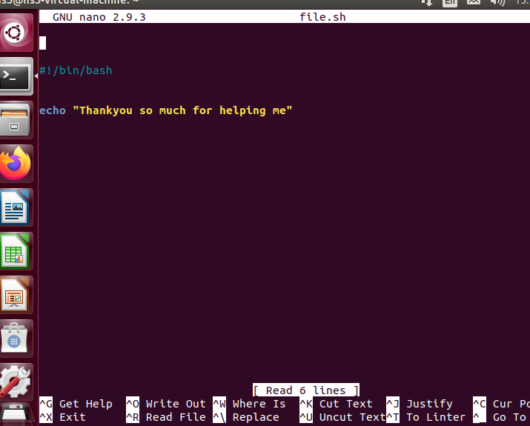

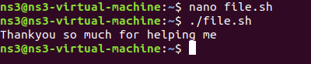

**Question 6:**

**#include<pthread.h>**

**#include<iostream>**

**#include<stdio.h>**

**#include<stdlib.h>**

**#include<unistd.h>**

**using namespace std;**

**int main()**

**{**

**int n = 3;**

**pid_t Parent ();**

**pid_t = fork();**

**pthread_args(addr, NULL, fork(), NULL);**

**pthread_args(addr, NULL, fork(), NULL);**

**pthread_args(addr, NULL, fork(), NULL);**

**for (int i = 0; i < n; i++)**

**{**

**pthread_create(&fork, NULL, fork1,NULL);**

**pthread_create(&fork, NULL, fork2,NULL);**

**pthread_create(&fork, NULL, fork3,NULL);**

**pid_t(i) Child = fork();**

**pid_t Child = exec()**

**}**

**pid_t Parent = wait();**

**for (int i = 0; i < n; i++)**

**{**

**printf(“%d”, "Im parent and my id is" %d, pid_t()\n”);**

**printf(“%d”, "Im child" , %d, i "and my id is "%d, pid_t(child)\n)**

**;}**

**}**

**Part 3**

**Question 1: Producer Consumer problem**

**#include<pthread.h>**

**#include<iostream>**

**#include<stdio.h>**

**#include<stdlib.h>**

**#include<unistd.h>**

**#include<string>**

**using namespace std;**

**int main()**

**{**

**int buffer = 10;**

**int producer;**

**string msg;**

**int maxsize = buffer;**

**int consumer;**

**// producer when creates a message**

**// enter the message inside buffer**

**//check if buffer is empty or not first**

**if (if buffer-1 != maxsize)**

**{**

**buffer = producer(message)**

**buffer = buffer+1; // message produced by the producer in buffer**

**// checking block chaining that is if both the sender and reciever are blocked**

**if(producer(0) == consumer(0))**

**then**

**{**

**cout<< "Message could not be passed as both the sender reciver are blocked and its a rendevous" << endl;**

**}**

**// consumer turn**

**if (producer(buffer) > consumer(buffer))**

**then**

**{**

**consumer buffer = out;**

**buffer --;**

**}**

**// consumer buffer has been decremented after getting the message consumed.**

**if (producer(buffer-1) == consumer(buffer-1)**

**{**

**//hold and wait**

**producer wait();**

**consumer wait();**

**if(producer(msg)!= consumser(msg(wait))**

**{**

**cout << "Producer will wait if there are no non consumers" << endl;**

**//last if condition of the producer consumer problem.**

**};**

